Overlapping

Definition
# Source: AI Source: Provided by: [Data Path: Persons Table -> ID Column: 1, Name_En Column: Motasem Essam] -> From: [ChatGPT] on [7/25/2026]
Overlapping is a geometric relationship in which two or more geometric objects share at least one common point or portion of space, while neither object necessarily contains the other completely.
For two geometric objects $A$and $B$, they overlap when their intersection contains a common geometric portion:
$$\boxed{A∩B≠∅}$$
For regions, overlapping usually means that the regions share a nonzero area or volume, rather than merely touching at a boundary point.
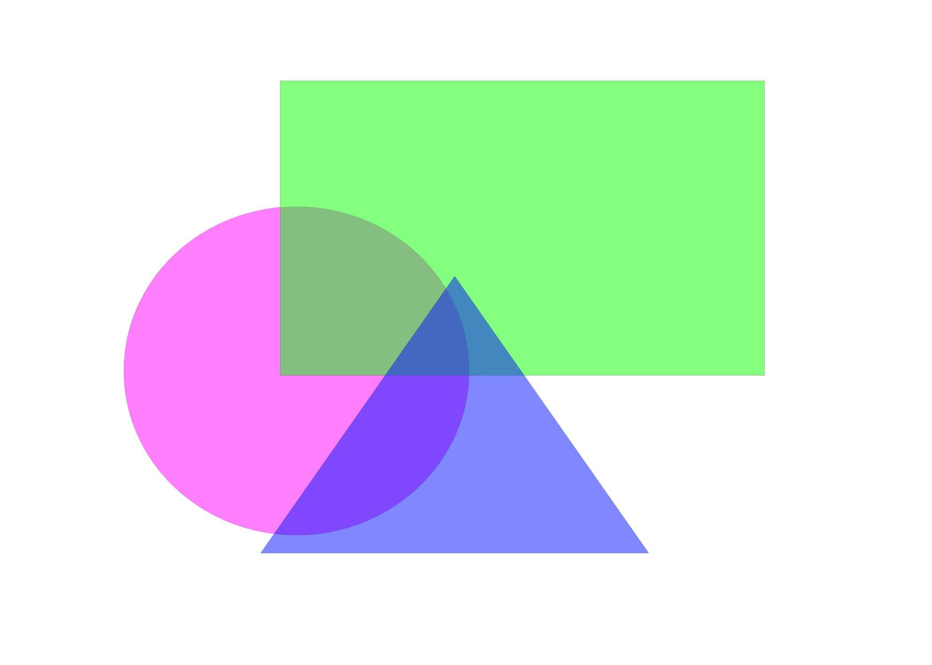
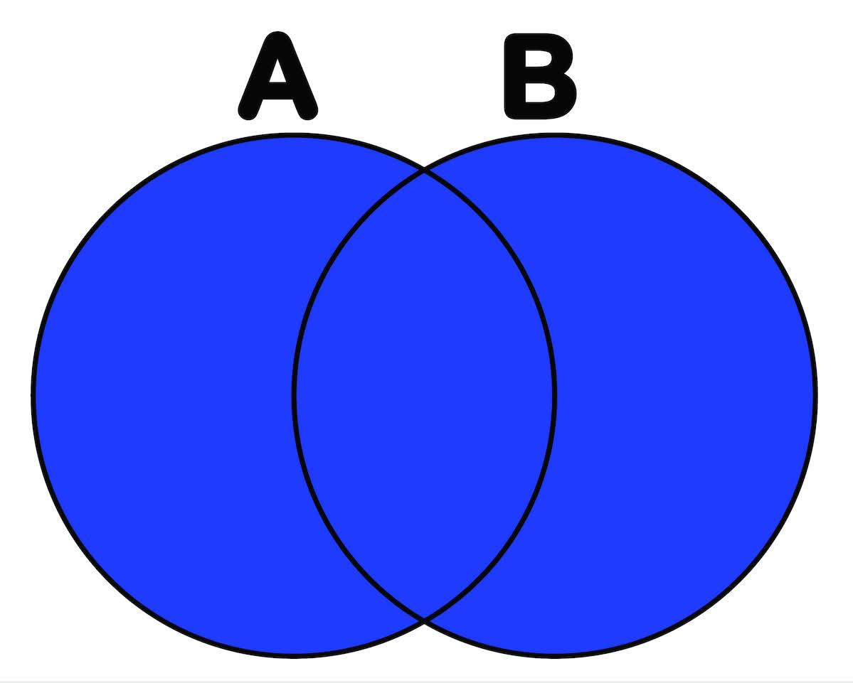
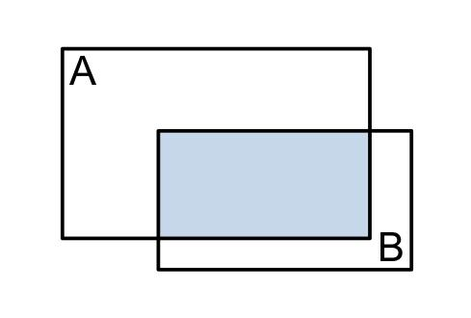
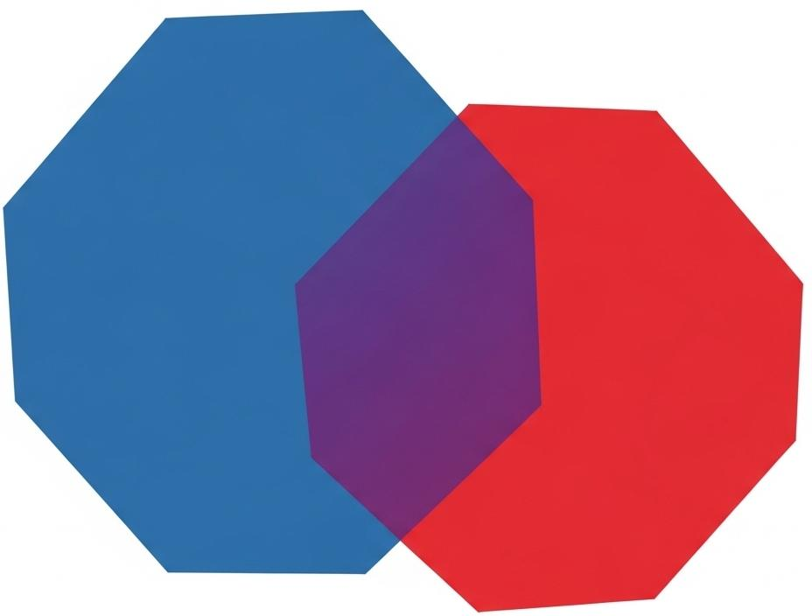
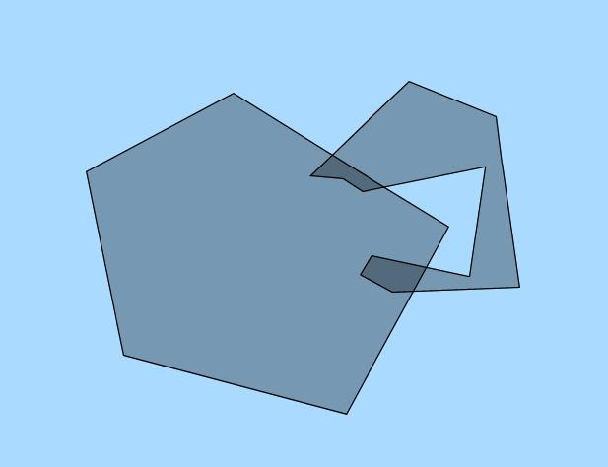

Purpose
# Source: AI Source: Provided by: [Data Path: Persons Table -> ID Column: 1, Name_En Column: Motasem Essam] -> From: [ChatGPT] on [7/25/2026]
The concept of Overlapping is used to describe geometric objects that occupy some of the same spatial extent.
It helps distinguish:
- overlapping objects,
- intersecting objects,
- touching objects,
- contained objects,
- coincident objects,
- and disjoint objects.
Overlapping is particularly important in geometry, CAD, computer graphics, GIS, robotics, and spatial analysis.

Fundamental Concept
# Source: AI Source: Provided by: [Data Path: Persons Table -> ID Column: 1, Name_En Column: Motasem Essam] -> From: [ChatGPT] on [7/25/2026]
The fundamental idea is shared geometric extent.
If two objects $A$and $B$overlap, then there is a portion that belongs to both:
$$\boxed{A∩B≠∅}$$
For regions, a stronger interpretation is commonly used:
$$\boxed{int⁡\left(A\right)∩int⁡\left(B\right)≠∅}$$
This means that their interiors share some points.
Therefore, two regions can overlap without one being completely contained in the other.

Mathematical Representation
# Source: AI Source: Provided by: [Data Path: Persons Table -> ID Column: 1, Name_En Column: Motasem Essam] -> From: [ChatGPT] on [7/25/2026]
The basic set-theoretic representation is:
$$\boxed{A∩B≠∅}$$
For two regions $R_{1}$and $R_{2}$:
$$\boxed{R_{1}∩R_{2}≠∅}$$
The common portion is called the intersection:
$$\boxed{R_{\text{overlap}}=R_{1}∩R_{2}}$$
For genuine area overlap:
$$\boxed{Area⁡\left(R_{1}∩R_{2}\right)>0}$$
For three-dimensional regions:
$$\boxed{Volume⁡\left(V_{1}∩V_{2}\right)>0}$$

Fundamental Elements
# Source: AI Source: Provided by: [Data Path: Persons Table -> ID Column: 1, Name_En Column: Motasem Essam] -> From: [ChatGPT] on [7/25/2026]
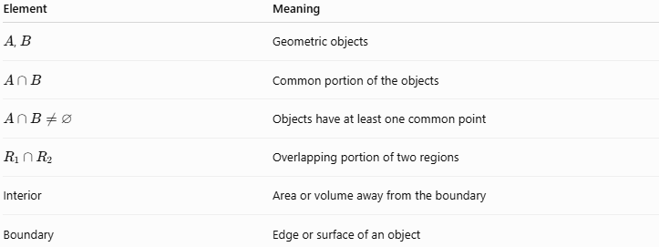
Element | Meaning
$A$, $B$ | Geometric objects
$$A∩B$$ | Common portion of the objects
$$A∩B≠∅$$ | Objects have at least one common point
$$R_{1}∩R_{2}$$ | Overlapping portion of two regions
Interior | Area or volume away from the boundary
Boundary | Edge or surface of an object

Example 1 – Two Overlapping Circles
# Source: AI Source: Provided by: [Data Path: Persons Table -> ID Column: 1, Name_En Column: Motasem Essam] -> From: [ChatGPT] on [7/25/2026]
Consider two circular regions whose centers are close enough that the circles partially cross.
Their common region is:
$$\boxed{R_{1}∩R_{2}}$$
and:
$$\boxed{Area⁡\left(R_{1}∩R_{2}\right)>0}$$
Neither circle completely contains the other.
This is a classic example of overlapping regions.

Example 2 – Overlapping Rectangles
# Source: AI Source: Provided by: [Data Path: Persons Table -> ID Column: 1, Name_En Column: Motasem Essam] -> From: [ChatGPT] on [7/25/2026]
Suppose:
$$R_{1}=\left\{\left(x , y\right) , ∣0≤x≤6 0≤y≤4\right\}$$
and:
$$R_{2}=\left\{\left(x , y\right) , ∣4≤x≤10 2≤y≤6\right\}$$
The common region satisfies:
$$4≤x≤6$$
and:
$$2≤y≤4$$
Therefore:
$$\boxed{R_{1}∩R_{2}=\left\{\left(x , y\right) , ∣4≤x≤6 2≤y≤4\right\}}$$
The rectangles overlap in a smaller rectangular region.

Example 3 – Overlapping Polygons
# Source: AI Source: Provided by: [Data Path: Persons Table -> ID Column: 1, Name_En Column: Motasem Essam] -> From: [ChatGPT] on [7/25/2026]
Two polygons may partially occupy the same area.
If:
$$P_{1}∩P_{2}≠∅$$
and neither polygon completely contains the other, they have an overlapping relationship.
The common area is:
$$\boxed{P_{1}∩P_{2}}$$

Overlapping vs Intersection
# Source: AI Source: Provided by: [Data Path: Persons Table -> ID Column: 1, Name_En Column: Motasem Essam] -> From: [ChatGPT] on [7/25/2026]
These terms are closely related but should not be treated as completely identical.
Intersection
Intersection is the mathematical operation that produces the common part:
$$\boxed{A∩B}$$
Overlapping
Overlapping describes the geometric relationship in which objects share some spatial extent.
Thus:
$$\boxed{\text{Intersection is the common part}}$$
while:
$$\boxed{\text{Overlapping is the relationship produced by shared extent}}$$
For example, two rectangles may overlap, and their intersection is the rectangular area they share.

Overlapping vs Touching
# Source: AI Source: Provided by: [Data Path: Persons Table -> ID Column: 1, Name_En Column: Motasem Essam] -> From: [ChatGPT] on [7/25/2026]
This distinction is important.
Overlapping
The objects share an actual region of positive area or volume:
$$\boxed{Area⁡\left(A∩B\right)>0}$$
Touching
The objects meet only at their boundaries or at a lower-dimensional set.
For example, two circles that touch at exactly one point have:
$$A∩B=\left\{P\right\}$$
but they do not have a common area.
Therefore, they are touching, not overlapping in the strict region sense.

Overlapping vs Proper Containment
# Source: AI Source: Provided by: [Data Path: Persons Table -> ID Column: 1, Name_En Column: Motasem Essam] -> From: [ChatGPT] on [7/25/2026]
Suppose:
$$R_{1}⊊R_{2}$$
Then:
$$R_{1}∩R_{2}=R_{1}$$
The regions share an area, but one region is completely contained within the other.
Therefore, in a strict geometric classification:
- Overlap usually refers to partial shared extent.
- Containment refers to complete inclusion.
A useful distinction is:
$$\boxed{\text{Overlap without containment}}$$
versus:
$$\boxed{\text{Containment}}$$

Overlapping vs Equal Regions
# Source: AI Source: Provided by: [Data Path: Persons Table -> ID Column: 1, Name_En Column: Motasem Essam] -> From: [ChatGPT] on [7/25/2026]
If:
$$R_{1}=R_{2}$$
then the regions obviously share all their points.
However, equality is a stronger and more specific relationship than ordinary overlapping.
Thus:
$$\boxed{R_{1}=R_{2}⇒R_{1}∩R_{2}≠∅}$$
for nonempty regions.
But:
$$\boxed{R_{1}∩R_{2}≠∅⇏R_{1}=R_{2}}$$

Overlapping vs Disjoint
# Source: AI Source: Provided by: [Data Path: Persons Table -> ID Column: 1, Name_En Column: Motasem Essam] -> From: [ChatGPT] on [7/25/2026]
Overlapping
$$\boxed{A∩B≠∅}$$
Disjoint
$$\boxed{A∩B=∅}$$
Thus, these relationships are opposites with respect to whether a common portion exists.

Properties of Overlapping

1. Symmetric
# Source: AI Source: Provided by: [Data Path: Persons Table -> ID Column: 1, Name_En Column: Motasem Essam] -> From: [ChatGPT] on [7/25/2026]
If:
$$A∩B≠∅$$
then:
$$\boxed{B∩A≠∅}$$
Therefore, overlapping is symmetric.

2. Not Transitive
# Source: AI Source: Provided by: [Data Path: Persons Table -> ID Column: 1, Name_En Column: Motasem Essam] -> From: [ChatGPT] on [7/25/2026]
Suppose:
$$A∩B≠∅$$
and:
$$B∩C≠∅$$
It does not necessarily follow that:
$$A∩C≠∅$$
Therefore:
$$\boxed{\text{Overlapping is not generally transitive}}$$
For example, three regions may form a chain where $A$overlaps $B$, and $B$overlaps $C$, but $A$and $C$are completely separate.

3. The Intersection Represents the Common Portion
# Source: AI Source: Provided by: [Data Path: Persons Table -> ID Column: 1, Name_En Column: Motasem Essam] -> From: [ChatGPT] on [7/25/2026]
If two objects overlap:
$$\boxed{A∩B}$$
represents the portion shared by both.

4. Overlap Can Have Different Dimensions
# Source: AI Source: Provided by: [Data Path: Persons Table -> ID Column: 1, Name_En Column: Motasem Essam] -> From: [ChatGPT] on [7/25/2026]
Two objects may share:
- a point,
- a line segment,
- an area,
- a surface,
- or a volume.
Therefore, the exact meaning of "overlap" depends on the geometric objects being considered.

Important Distinction: General Intersection vs Genuine Overlap
# Source: AI Source: Provided by: [Data Path: Persons Table -> ID Column: 1, Name_En Column: Motasem Essam] -> From: [ChatGPT] on [7/25/2026]
For your geometry knowledge base, I recommend making this distinction explicit.
The condition:
$$A∩B≠∅$$
is the general definition of nonempty intersection.
But for regions, "overlapping" is often better defined as sharing an interior portion:
$$\boxed{int⁡\left(R_{1}\right)∩int⁡\left(R_{2}\right)≠∅}$$
This prevents cases such as two regions merely touching at one boundary point from being classified as overlapping.
Therefore:
General intersection
$$A∩B≠∅$$
Region overlap
$$\boxed{int⁡\left(R_{1}\right)∩int⁡\left(R_{2}\right)≠∅}$$
This is the more precise definition I recommend for your taxonomy.

Comparison with Related Geometric Relationships
# Source: AI Source: Provided by: [Data Path: Persons Table -> ID Column: 1, Name_En Column: Motasem Essam] -> From: [ChatGPT] on [7/25/2026]
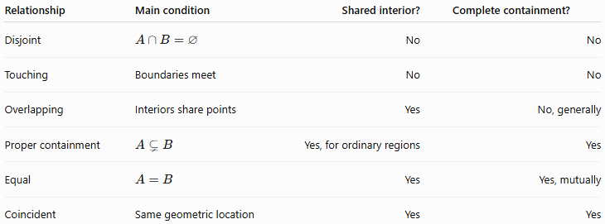
Relationship | Main condition | Shared interior? | Complete containment?
Disjoint | $$A∩B=∅$$ | No | No
Touching | Boundaries meet | No | No
Overlapping | Interiors share points | Yes | No, generally
Proper containment | $$A⊊B$$ | Yes, for ordinary regions | Yes
Equal | $$A=B$$ | Yes | Yes, mutually
Coincident | Same geometric location | Yes | Yes

Overlap in Two Dimensions
# Source: AI Source: Provided by: [Data Path: Persons Table -> ID Column: 1, Name_En Column: Motasem Essam] -> From: [ChatGPT] on [7/25/2026]
For planar regions:
$$\boxed{Area⁡\left(R_{1}∩R_{2}\right)>0}$$
is a useful practical test for genuine area overlap.
For example, if:
$$A\left(R_{1}∩R_{2}\right)=12{\text{ cm}}^{2}$$
then the regions have an overlapping area of:
$$\boxed{12{\text{ cm}}^{2}}$$

Overlap in Three Dimensions
# Source: AI Source: Provided by: [Data Path: Persons Table -> ID Column: 1, Name_En Column: Motasem Essam] -> From: [ChatGPT] on [7/25/2026]
For solids:
$$\boxed{Volume⁡\left(V_{1}∩V_{2}\right)>0}$$
indicates genuine volumetric overlap.
For example, two solid objects in CAD may occupy some of the same volume. This can indicate an unwanted physical collision or interference.

Relationship with Containment
# Source: AI Source: Provided by: [Data Path: Persons Table -> ID Column: 1, Name_En Column: Motasem Essam] -> From: [ChatGPT] on [7/25/2026]
Containment and overlap are closely related but should remain separate categories.
If:
$$R_{1}⊊R_{2}$$
then the regions share an area, but the relationship is more specifically containment.
If neither contains the other and:
$$int⁡\left(R_{1}\right)∩int⁡\left(R_{2}\right)≠∅$$
then the relationship is partial overlap.
Therefore:
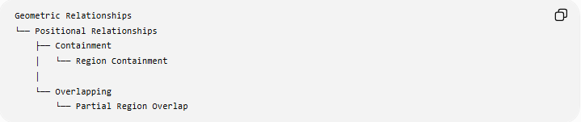
Geometric Relationships
└── Positional Relationships
├── Containment
│ └── Region Containment
│
└── Overlapping
└── Partial Region Overlap
This keeps Containment and Overlapping as separate positional relationships.

Real-World Applications
# Source: AI Source: Provided by: [Data Path: Persons Table -> ID Column: 1, Name_En Column: Motasem Essam] -> From: [ChatGPT] on [7/25/2026]
Computer-Aided Design
Detecting whether two components occupy the same space:
$$\boxed{Volume⁡\left(A∩B\right)>0}$$
can identify physical interference.
Computer Graphics
Overlapping shapes can be combined, clipped, or detected for collision purposes.
GIS
Geographic regions such as administrative boundaries, flood zones, and land-use areas can overlap.
Robotics
Two moving objects can be checked for overlapping spatial regions to detect collisions.
Image Processing
Two regions of interest may overlap in an image, allowing their common pixels to be identified.
Architecture
Different functional areas of a plan can be checked for unwanted spatial overlap.

Key Points
# Source: AI Source: Provided by: [Data Path: Persons Table -> ID Column: 1, Name_En Column: Motasem Essam] -> From: [ChatGPT] on [7/25/2026]
- Overlapping describes objects that share some common spatial extent.
- For regions, the most useful strict condition is:
$$\boxed{int⁡\left(R_{1}\right)∩int⁡\left(R_{2}\right)≠∅}$$
- The common portion is represented by:
$$\boxed{R_{1}∩R_{2}}$$
- In 2D, genuine overlap normally has positive area.
- In 3D, genuine overlap normally has positive volume.
- Overlapping is symmetric but generally not transitive.
- Touching is different from overlapping when the objects share only a boundary.
- Containment is more specific than general overlap because one object lies completely within another.
- Equal regions share everything but are better classified as equality/coincidence.

Conclusion
# Source: AI Source: Provided by: [Data Path: Persons Table -> ID Column: 1, Name_En Column: Motasem Essam] -> From: [ChatGPT] on [7/25/2026]
Overlapping is a positional geometric relationship in which two regions share a common interior portion without one necessarily being completely contained within the other.
For a rigorous region-based definition:
$$\boxed{int⁡\left(R_{1}\right)∩int⁡\left(R_{2}\right)≠∅}$$
and the actual common portion is:
$$\boxed{R_{1}∩R_{2}}$$
For your knowledge-base taxonomy, I recommend keeping Overlapping as a separate type under Geometric Relationships → Positional Relationships, alongside Containment, Touching, Intersection and Coincidence/Equality.

